Sao Tome and Principe

## Population Data

The data set shows the political stability estimate of the country each year.

## # A tibble: 23 x 5  
## country iso3c date population popCategory5  
## <chr> <chr> <dbl> <dbl> <chr>   
## 1 Sao Tome and Principe STP 1996 133806 very small   
## 2 Sao Tome and Principe STP 1997 135832 very small   
## 3 Sao Tome and Principe STP 1998 137848 very small   
## 4 Sao Tome and Principe STP 1999 139959 very small   
## 5 Sao Tome and Principe STP 2000 142262 very small   
## 6 Sao Tome and Principe STP 2001 144755 very small   
## 7 Sao Tome and Principe STP 2002 147447 very small   
## 8 Sao Tome and Principe STP 2003 150415 very small   
## 9 Sao Tome and Principe STP 2004 153737 very small   
## 10 Sao Tome and Principe STP 2005 157472 very small   
## 11 Sao Tome and Principe STP 2006 161681 very small   
## 12 Sao Tome and Principe STP 2007 166300 very small   
## 13 Sao Tome and Principe STP 2008 171120 very small   
## 14 Sao Tome and Principe STP 2009 175876 very small   
## 15 Sao Tome and Principe STP 2010 180371 very small   
## 16 Sao Tome and Principe STP 2011 184524 very small   
## 17 Sao Tome and Principe STP 2012 188404 very small   
## 18 Sao Tome and Principe STP 2013 192087 very small   
## 19 Sao Tome and Principe STP 2014 195727 very small   
## 20 Sao Tome and Principe STP 2015 199432 very small   
## 21 Sao Tome and Principe STP 2016 203227 very small   
## 22 Sao Tome and Principe STP 2017 207089 very small   
## 23 Sao Tome and Principe STP 2018 211028 very small

# Population growth data

## # A tibble: 23 x 5  
## country iso3c date popGrowth popGrowthCat5   
## <chr> <chr> <dbl> <dbl> <chr>   
## 1 Sao Tome and Principe STP 1996 1.60 moderate growth rate  
## 2 Sao Tome and Principe STP 1997 1.50 moderate growth rate  
## 3 Sao Tome and Principe STP 1998 1.47 slow growth rate   
## 4 Sao Tome and Principe STP 1999 1.52 moderate growth rate  
## 5 Sao Tome and Principe STP 2000 1.63 moderate growth rate  
## 6 Sao Tome and Principe STP 2001 1.74 moderate growth rate  
## 7 Sao Tome and Principe STP 2002 1.84 moderate growth rate  
## 8 Sao Tome and Principe STP 2003 1.99 moderate growth rate  
## 9 Sao Tome and Principe STP 2004 2.18 moderate growth rate  
## 10 Sao Tome and Principe STP 2005 2.40 moderate growth rate  
## 11 Sao Tome and Principe STP 2006 2.64 high growth rate   
## 12 Sao Tome and Principe STP 2007 2.82 high growth rate   
## 13 Sao Tome and Principe STP 2008 2.86 high growth rate   
## 14 Sao Tome and Principe STP 2009 2.74 high growth rate   
## 15 Sao Tome and Principe STP 2010 2.52 high growth rate   
## 16 Sao Tome and Principe STP 2011 2.28 moderate growth rate  
## 17 Sao Tome and Principe STP 2012 2.08 moderate growth rate  
## 18 Sao Tome and Principe STP 2013 1.94 moderate growth rate  
## 19 Sao Tome and Principe STP 2014 1.88 moderate growth rate  
## 20 Sao Tome and Principe STP 2015 1.88 moderate growth rate  
## 21 Sao Tome and Principe STP 2016 1.89 moderate growth rate  
## 22 Sao Tome and Principe STP 2017 1.88 moderate growth rate  
## 23 Sao Tome and Principe STP 2018 1.88 moderate growth rate

## Population trend

The plot shows the population trend of the country.

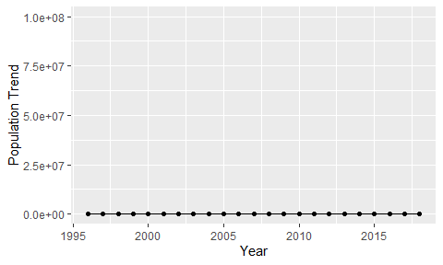

Political Stability Trend

# Population growth trend

The plot shows the population growth rate trend of the country.

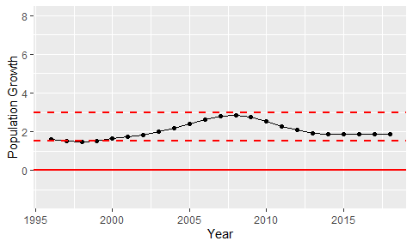

Population Growth Trend